Middleware

Middleware is a module or program which performs 2 operations
- Pre-request
- Post-response

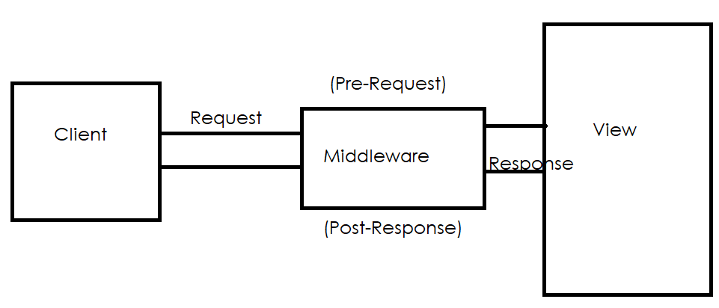

Middleware’s are 2 types
- Predefined middleware’s
- User defined middleware’s
Predefined middleware’s are nothing existing middleware’s or middleware’s provided by django.
Whenever project is created, it create with some predefined middleware’s

Settings.py
MIDDLEWARE = [
'django.middleware.security.SecurityMiddleware',
'django.contrib.sessions.middleware.SessionMiddleware',
'django.middleware.common.CommonMiddleware',
'django.middleware.csrf.CsrfViewMiddleware',
'django.contrib.auth.middleware.AuthenticationMiddleware',
'django.contrib.messages.middleware.MessageMiddleware',
'django.middleware.clickjacking.XFrameOptionsMiddleware',
]

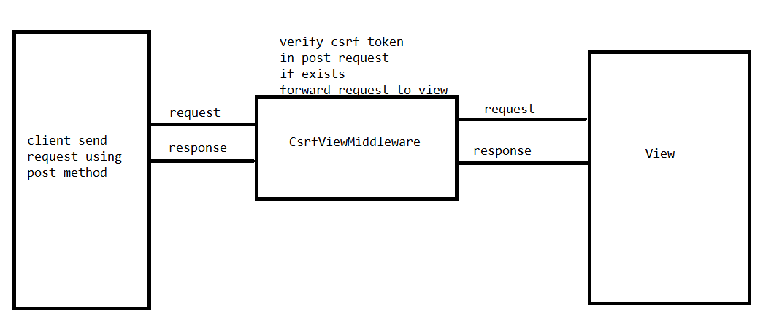

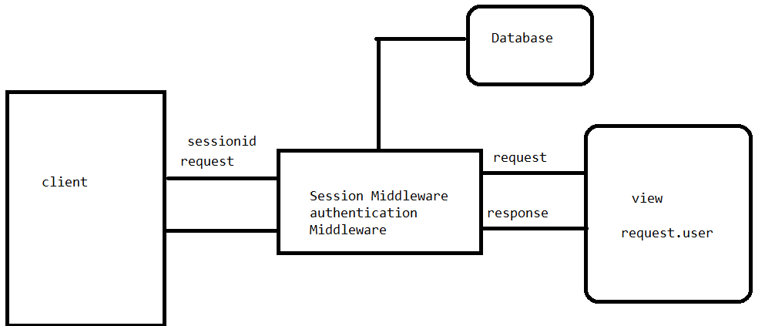

What is pre-request?
Middleware is executed before sending request to the view, this is called pre-request.

What is post-response?
Middleware is executed before sending response to the view, tthis is called post response.

Real time applications of middleware
Common Applications of Custom Middleware
- Authentication & Access Control: While Django has built-in auth, custom middleware can implement specialized logic, such as restricting access by IP address or redirecting users to specific homepages based on their roles (e.g., student vs. teacher) immediately after login.
- Logging & Monitoring: You can create middleware to log incoming request data (like IP addresses, user agents, or paths), track slow database queries, or send error notifications to external services.
- Performance Tracking: Custom middleware is often used to measure response times or gather statistics on page usage, helping identify performance bottlenecks globally.
- Request & Response Modification: You can globally add custom HTTP headers, inject static information (like a site-wide URL) into templates, or even transform HTML output before it reaches the client.

Basic steps to work with middleware
- Creating middleware
- Register middleware or configure middleware

Creating middleware
Middleware is represented or created using class.

Syntax:
class middleware-name:
def __init__(self,get_response):
self.response=get_response
def __call__(self,request):
pre-request (OR) logic before sending request to view
send request to view
post-response (OR) logic before sending response to client

__call__ is magic method, this method makes your object is callable.
Middleware logic is written inside __call_ method.

Register middleware
Middleware is registered at project level
Middleware is applicable to all the application exists in project
A project is registered with one or more than one middleware and all the middleware’s executed the order in which it is defined inside settings.py

MIDDLEWARE = [
'django.middleware.security.SecurityMiddleware',
'django.contrib.sessions.middleware.SessionMiddleware',
'django.middleware.common.CommonMiddleware',
'django.middleware.csrf.CsrfViewMiddleware',
'django.contrib.auth.middleware.AuthenticationMiddleware',
'django.contrib.messages.middleware.MessageMiddleware',
'django.middleware.clickjacking.XFrameOptionsMiddleware',
]

Create a folder inside project container folder (middleware)
First.py
class FirstMiddleware:
def __init__(self,get_response):
self.get_response=get_response
def __call__(self,request):
print("before sending request to view")
response=self.get_response(request)
print("before sending response to client")
return response

views.py
from django.shortcuts import render
from django.http import HttpResponse
# Create your views here.

def view1(request):
print("inside view")
response=HttpResponse("<h2>This is output of view1 </h2>")
return response

settings.py
INSTALLED_APPS = [
'django.contrib.admin',
'django.contrib.auth',
'django.contrib.contenttypes',
'django.contrib.sessions',
'django.contrib.messages',
'django.contrib.staticfiles',
'app',
]

MIDDLEWARE = [
'middleware.first.FirstMiddleware',
'django.middleware.security.SecurityMiddleware',
'django.contrib.sessions.middleware.SessionMiddleware',
'django.middleware.common.CommonMiddleware',
'django.middleware.csrf.CsrfViewMiddleware',
'django.contrib.auth.middleware.AuthenticationMiddleware',
'django.contrib.messages.middleware.MessageMiddleware',
'django.middleware.clickjacking.XFrameOptionsMiddleware',

]

Urls.py
from django.contrib import admin
from django.urls import path
from app.views import view1
urlpatterns = [
path('admin/', admin.site.urls),
path('view1/',view1),
]

